Peace and Reconciliation Working Group

-

Iraq

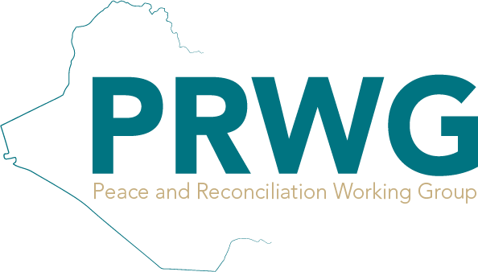

# PRWG Mandate, Vision, and Goals

The Peace and Reconciliation Working Group - Iraq is a coordination platform that brings together circa two hundred local and international peacebuilding organisations, government representatives as well as UN agencies and donors. The aim of this coordination mechanism is to share capacity while integrating broader development and systems approaches to peacebuilding and to reduce duplication of peacebuilding programmes and address gaps.

# PRWG Background

Since its establishment in August 2018, the PRWG - Iraq has successfully run monthly coordination meetings and strategic planning sessions whereby different thematic and operational topics relevant to the emerging context in Nineveh were introduced and discussed. These efforts have resulted in improved coordination in the design and implementation of peacebuilding programming and increased awareness and knowledge of peacebuilding efforts among local and international actors.

The PRWG - Iraq has also run several thematic taskforce meetings to increase synergies between the various peacebuilding actors and practitioners, such as the Local Peace Committees (LPCs) and Advocacy Taskforces, which enhanced coordination and created a concerted approach in communicating with the government and the targeted communities and stakeholders.

The PRWG - Iraq has hosted a range of subject matter experts, government officials, and donors. The PRWG - Iraq, as a coordination mechanism, was also successful in bringing together different clusters/working groups such as the Return Working Group, and the Protection Cluster, facilitating a collaborative working environment towards the realisation of the goal against which the PRWG - Iraq has been established.

The PRWG - Iraq is comprised of two chairs: the Secretariat, the Technical Coordinator along with local and national Government Representation. In accordance with the PRWG - Iraq’s Terms of References (ToRs), both the Secretariat and the Technical Coordinator are annually elected by the members of the PRWG - Iraq.

In 2022 took the bold leap towards localisation and become the first working group in Iraq that is led by a local NGO and in 2023 the PRWG - Iraq engaged the private sector to support its efforts in Nineveh governorate.

In 2024, the PRWG - Iraq expanded its efforts to cover Diyala, Anbar, Salaheddin, Kirkuk and Nineveh governorates; and this expansion was advanced in 2025 to include Baghdad, Basra, Nasiriyya and Najaf governorates with the objective of expanding its coverage across all of Iraq in 2026.

In 2023, the Sustainable Peace Foundation (SPF) was elected to host, starting from January 2024, both the Secretariat and Technical Coordination of the PRWG – Iraq. This leadership role is supported by the International Rescue Committee (IRC), which serves as co-chair and provides ongoing technical backstopping. To ensure inclusive governance and strategic direction, PRWG is further guided by a Steering Committee comprised of SPF, IRC, UNDP, Un Ponte Per (UPP), and Jiyan Foundation.